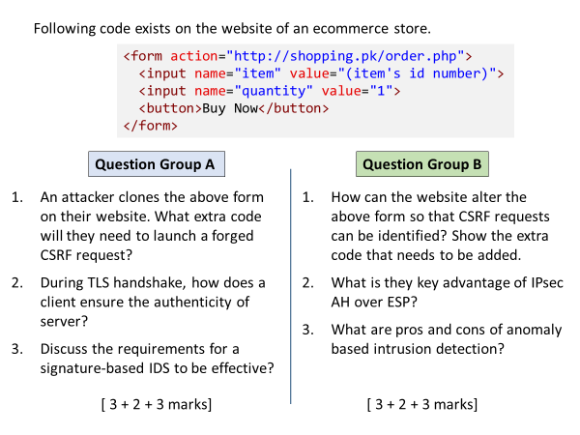
A
1
<script> document.forms[0].submit(); </script>
above code line causes the form to auto submit. Alternatively, they can also submit the form in response to a user action (e.g. click on a different button)
2
Server shares its public key certificate to client, which client can check if valid, it treats the server as authentic.
3
- Signatures database should be sufficiently large
- Signatures are continuously updated with the new attack patterns.

B
1
add a hidden field containing STP token as its value
<input type=”hidden” name=”token” value=”(STP token)” />
2
AH coverage includes the IP packer header, while ESP protects the payload only.
3
Pros: recognize new/novel attacks for which signatures haven’t been collected
Cons: high rate of false positives.

